**HL Unit 7** **– Control**  
Test 1

1. A biotechnology company owns a resource centre which collects and classifies organisms

for use in research.

Only authorized employees are allowed access to some laboratories in the resource centre.

These laboratories are protected by locked doors. Each door is controlled by a separate microprocessor. A digital camera is used to scan the iris of an employee who wishes to

enter the lab. If the employee is authorized the doors are unlocked.

1. Identify **two** benefits of using a digital camera as an input device in this control system. [2]

*Award up to* ***[2 max]****.*

***([1]*** *for each of the* ***two*** *benefits).*

Digital cameras are relatively cheap;

Robust;

No need for AD conversion;

Generally very high quality pictures (useful to prevent malpractice);

Generally quick;

***Example answer 1***

No need for conversion because image is in digital format;

Thousands/millions of photos of eyes could be taken before needing replacement;

***Example answer 2***

It is directly connected to a microprocessor for image comparison;

It could be fitted (purchased), with a macro lens so that a close up scan of the

Iris is possible;

1. Outline the use of a microprocessor in this control system. [2]

*Award up to* ***[2 max]****.*

Processor compares the inputted image/pattern with the images stored in memory;

If a match is found, it sends a signal to unlock doors /

(if match is not found, it sends error message/the doors remain locked);

1. Outline the function of an output transducer. [2]

Output transducer is a device (an actuator) which converts;

an electrical signal into physical quantity (a physical action);

Output transducer is a device which converts energy from one physical form to

another;

*eg* electrical energy (signal) into electro-mechanical or kinetic energy / to produce

action (lock/unlock door);

***Note****: Award one mark only for an answer that just says that the output*

*transducer can be used to lock/unlock doors.*

The company is planning to use a centralized computer system to secure the resource  
 centre’s building.

1. Compare a centrally controlled system with the system described above. [4]

*Award* ***[1]*** *for the meaning of centrally controlled system;*

***[1]*** *for the meaning of a distributed system, and;*

***[up to 2 max]*** *for an expansion/comparison addressing both kind of systems*

***[up to 4 max];***

***Example answer***

A centrally controlled system involves a central computer which controls all

labs/doors;

A distributed system can have only a dedicated microprocessor with memory to

control one of the labs/doors;

A centrally controlled system is more versatile;

Could be used in solving other business tasks (accept specific examples);

Can unlock all doors easily during an emergency;

Access rights can be updated easily;

Data is stored centrally and therefore easier to update;

A failure in a central system would affect all doors;

A distributed system can be programmed with ad hoc OS depending on the

technologies used;

It may be practical choice when dealing with legacy systems/ specific devices/

old infrastructure/while updating the facilities;

It contributes a higher sense of partition of the physical space (territory) to groups

/ individuals;

Data are stored locally, so there is local consistency (and smaller size mean

easier to manage);

Changes to data may be done locally, and if some data are common in two or

more different

systems, global inconsistencies across different systems may be

introduced;

The operating system has an important role in this system.

1. Identify **two** functions of the operating system. [2]

*Award* ***[2 max]****.*

Memory management;

Resource allocation / Resource and Hardware management (printer, disk drives,

*etc*.);

Booting / bootstrapping;

Loading and execute / provide service for applications software;

Disk/File system management;

Data security;

Provides a user interface to other levels of the machine;

*etc*.

Polling and interrupt are two operating system management techniques.

1. Suggest with reasons which of these two techniques is the most appropriate for   
   this centrally controlled system. [3]

*Award* ***[1]*** *for choosing “interrupt”,* ***[1]*** *for explaining “interrupts” and* ***[1]*** *for*

*justifying the choice in this context, up to* ***[3 max]****.*

***Example answer:***

Interrupt;

A signal sent from an input device to a computer causes the processor, and the

main program that operates the computer (the operating system), to stop and

figure out what to do next;

Interrupt is better in this situation because it does not waste central computer’s

time (other tasks could be performed);

*(example of emergency – it must give quick response);*

***Note:*** *Award* ***[1 max]*** *for an answer of “polling”, but only if reasonably justified.*

Polling – the continuous checking of all input devices by processor to see what

state they are in/to see whether they are still connected/want to communicate;

So a faulty device that is polled will not reply;

1. An embedded system is used to control the speed of an electric motor.
2. With reference to the example, above, define an embedded system. [2]

*Award up to* ***[2 max]****.*

An embedded system is a system that performs a specific/dedicated function;

For a larger system for which it is physically part of:

In this example, the control system is actually part of the electric motor;

The diagram shows the main components in a typical negative feedback system.

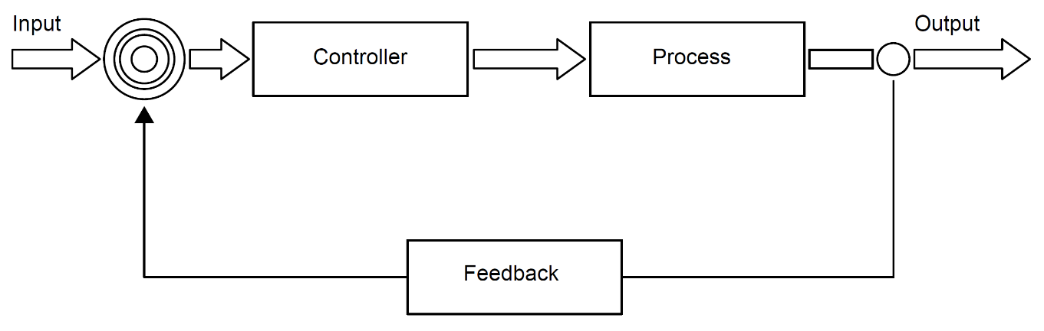

The control system for the electric motor consists of a negative feedback loop.

1. Outline the desired outcome of any feedback system. [2]

To control the output (values);

By keeping it close to the reference/input value;

***OR***

To control the system performance/behaviour of the system/;

by routing back the output values as input values;

(which are used to make decisions on changing/modifying the performance of the system/behaviour of the system);

1. List the steps involved in the feedback system for the electric motor. You should make   
   use of the appropriate technical terms of the control system process. [6]

*Award up to* ***[6 max]****.*

The desired speed is set/inputted and the (speed) sensor / input transducer measures the (current output) speed;

This analog signal (from the speed sensor) is converted into digital;

And sent back to the controller/processor;

The error/difference between the output speed and desired/input speed is calculated and compared to pre-set values to determine whether speed should be adjusted;

If the speed/power should be adjusted by an amount dependent upon the error then signal is sent to the output (transducer);

The above process is repeated continually;

A more complex control system is used to monitor and control the functioning of a power station. This includes a dedicated operating system with sensors and output transducers (actuators) placed at various places around the power station.

1. Explain the interaction between the components identified above, if interrupts are   
   generated by the sensors. [5]

The sensor sends an interrupt to the operating system;

When it measures a value outside of the normal range;

Such as an abnormal temperature/pressure;

The operating system sends a signal to operate an actuator (output transducer);

In order to bring the system back to normal;

1. Discuss **one** ethical consideration of using CCTV in a workplace. [3]

*Award* ***[1]*** *for a rationale,* ***[1]*** *for an example of misuse, and* ***[1]*** *for a way to prevent it, up to* ***[3 max]****.*

*The rationale:*

The right of the company to protect their premises/assets/IP shall not invade privacy rights of the employee;

Therefore precise guidelines must be set to prevent misuse of technology from the employer and ensure rights to the employee;

*Examples of Misuse:*

CCTV might not be used for surveillance only, but also to monitor employees;

It is a threat to personal privacy through intimidation/harassment/checking absentees/screening with consequences on quality of life/wellbeing/employment;

*For example:* monitoring employee’s activities/look for negative behaviour/gestures / focusing on some groups of employees (women/LGBT/ethnic or faith groups, *etc*);

*For example:* different cultures may interpret gestures in different ways, and this might be used to reprimand an employee;

Moving equipment (also a USB stick with data) from one building to another is monitored, but the footage can be interpreted as theft;

*Prevent Misuse:*

A secondary system for labelling equipment should be used (tagging items), to avoid misinterpretations, and discharge incorrect incriminations (but it is more subtle with IP);

Problem of where the footage is stored (company premises), for how long, and who has access to the information, for what use, shall also be addressed;

Surveillance staff (*ie* those who have access to CCTV footage) shall not be employees of the company or there could be internal conflicting situations (*ie* an employee controlling another employee);